Question 3 Queries & Results

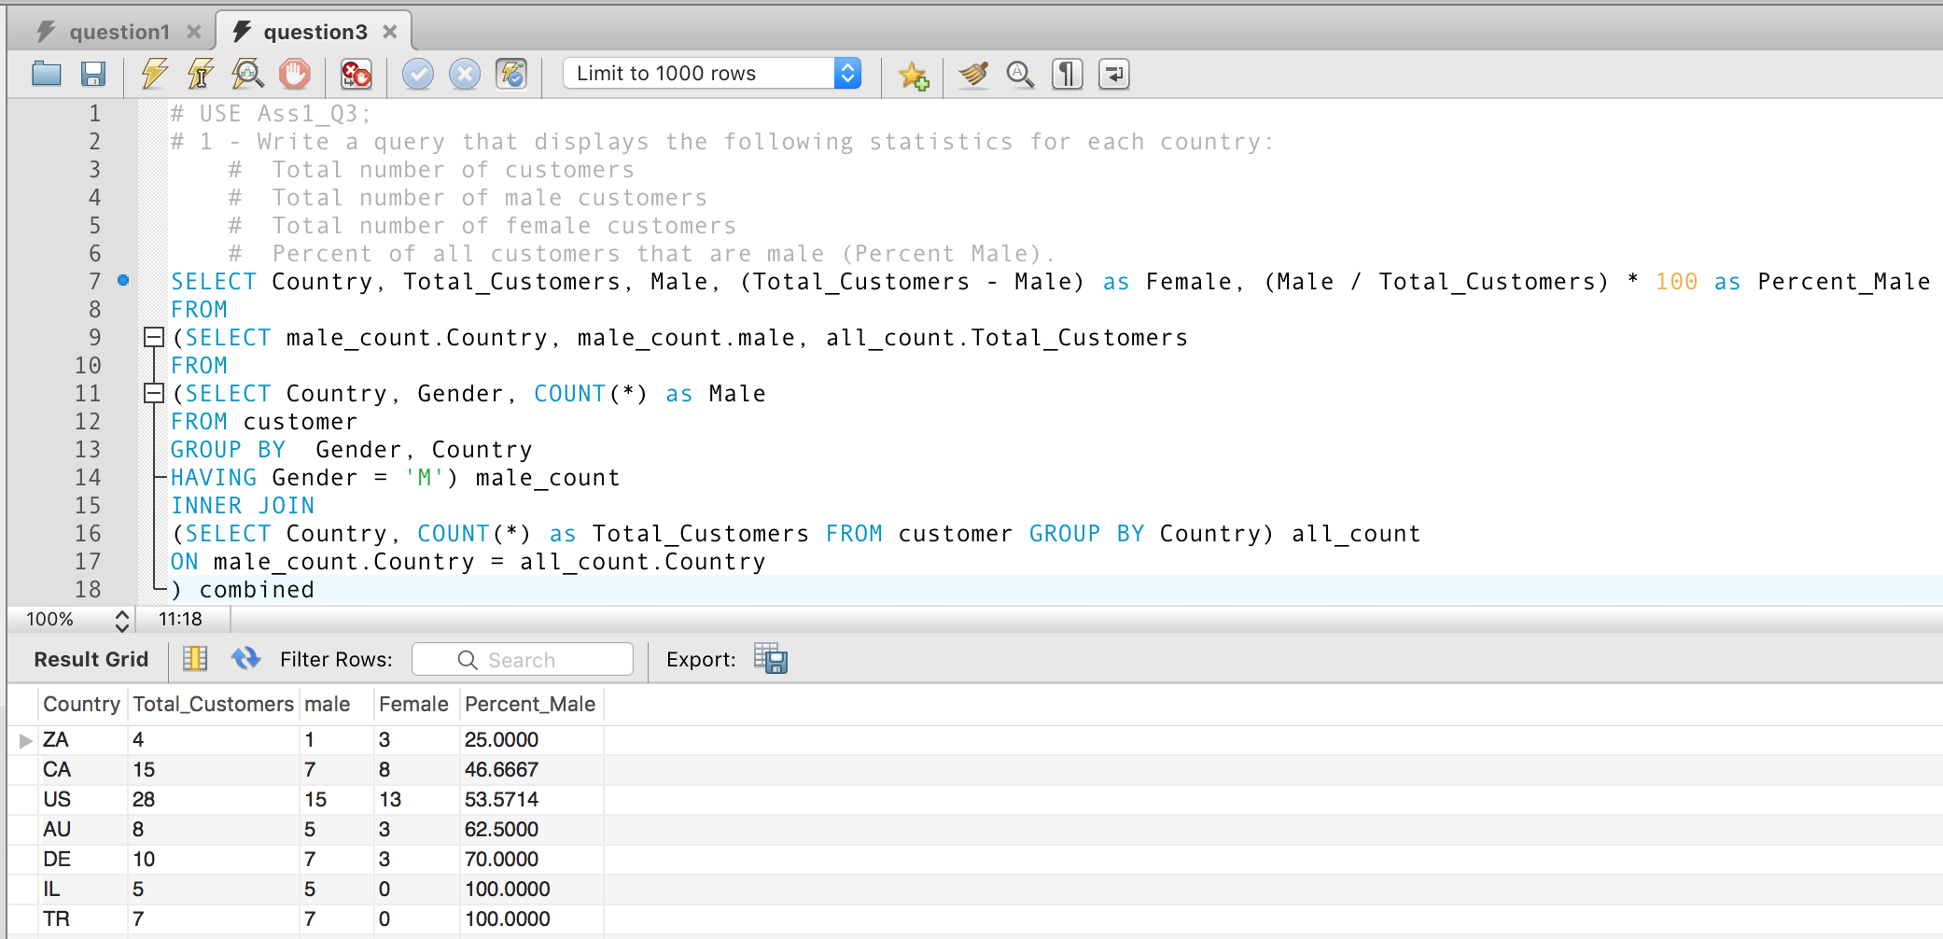

Figure1: Q3/1 Expression & Output

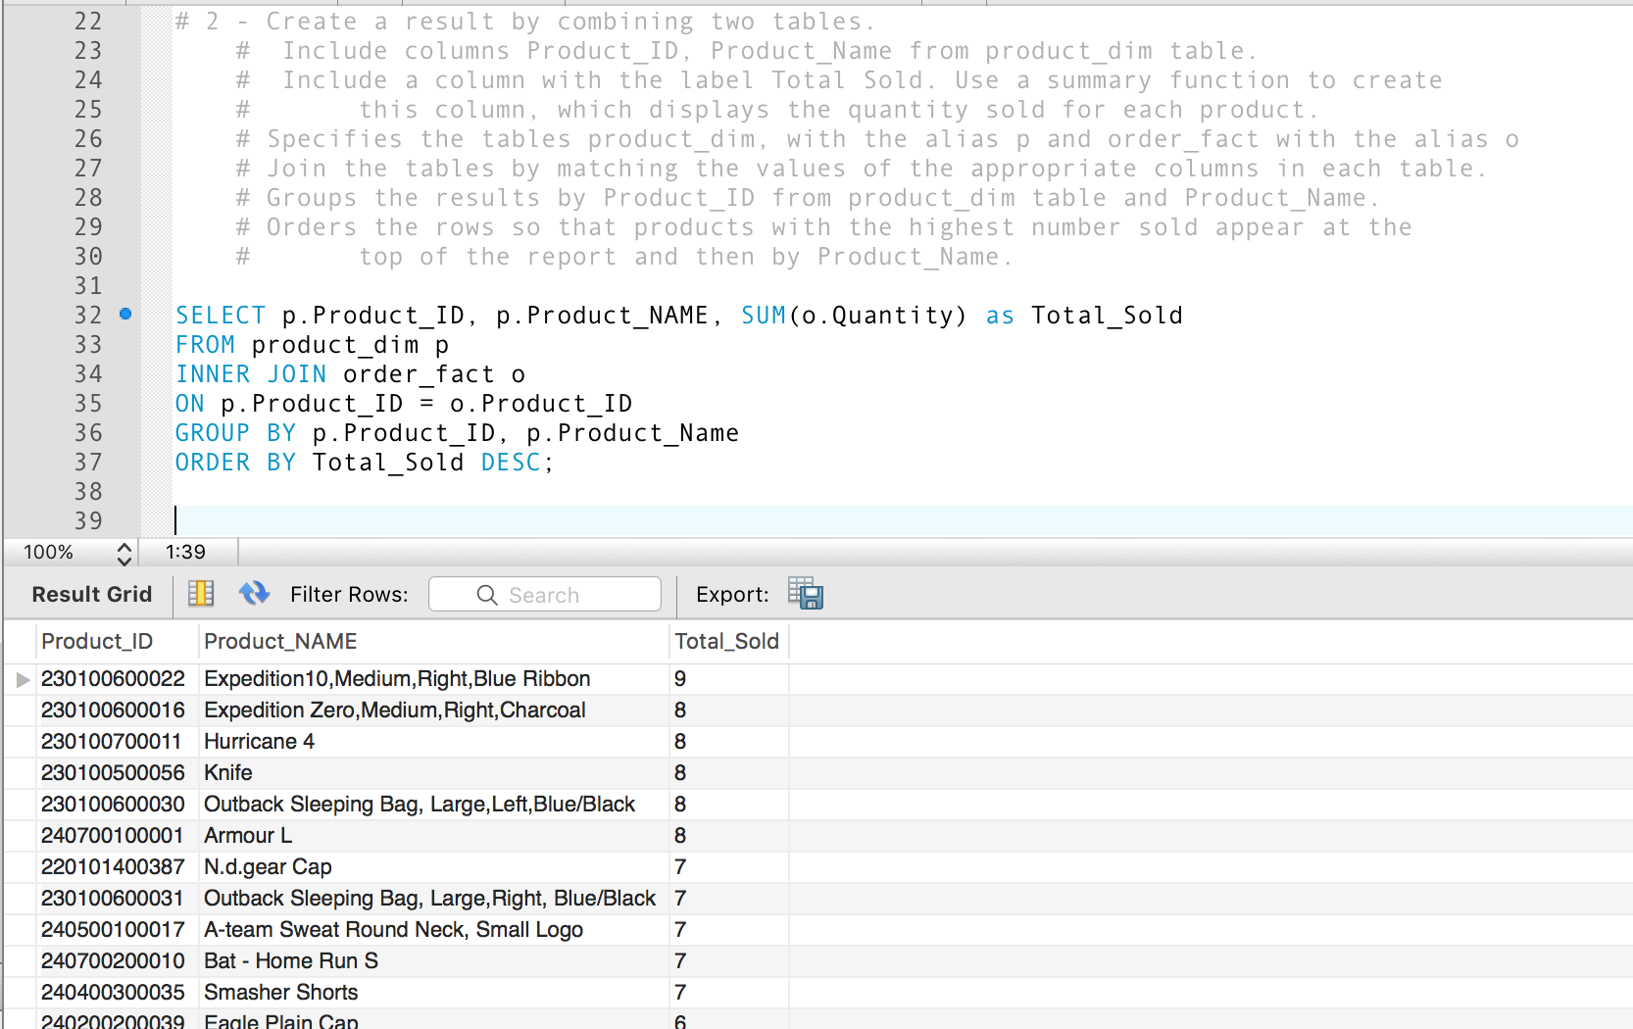

Figure2: Q3/2 Expression & Output – Displays 12 of 481

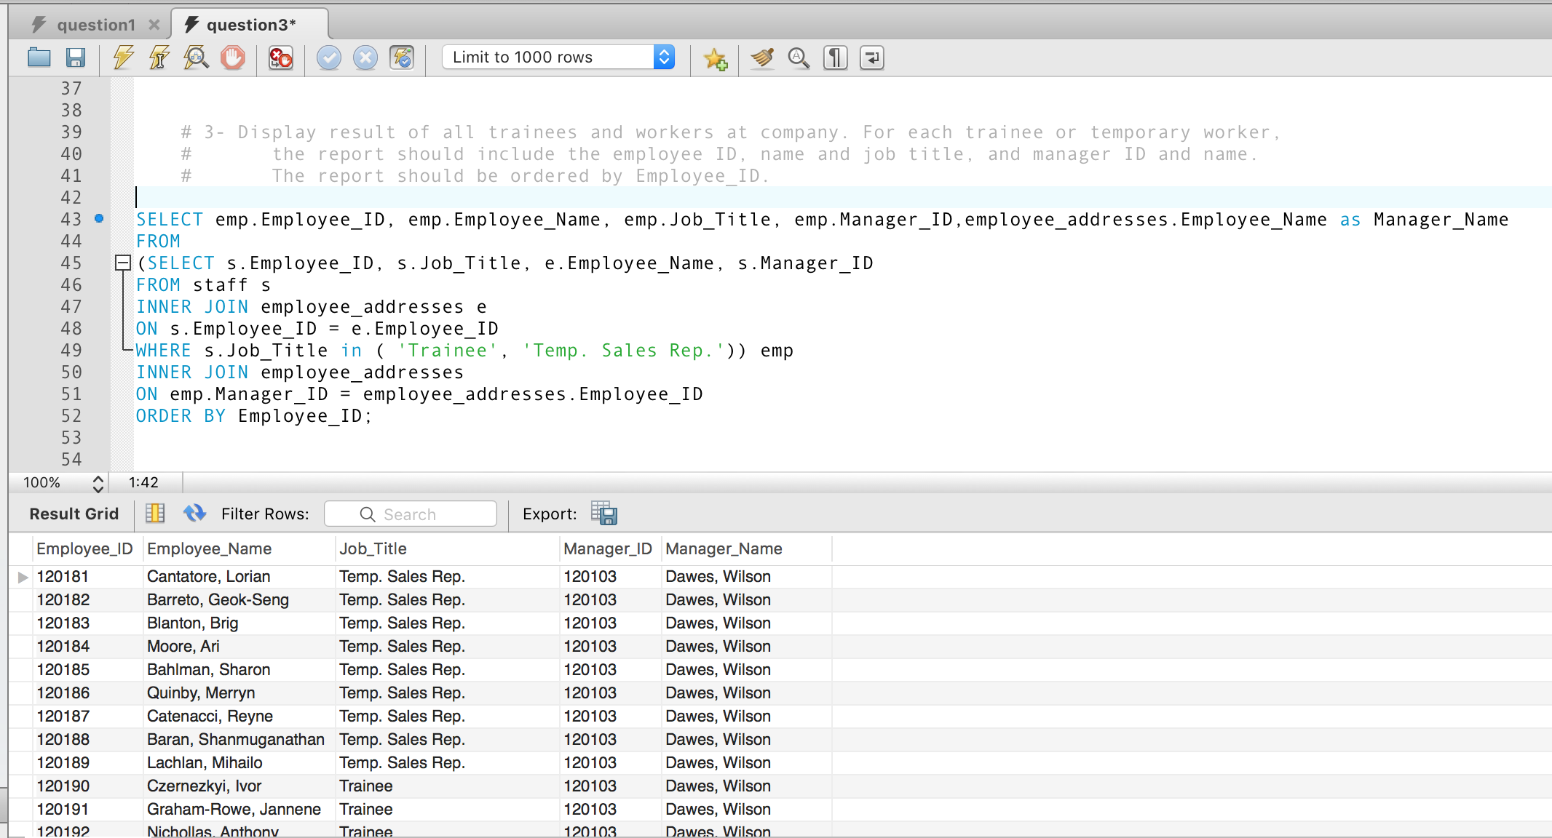

Figure3: Q3/3 Expression & Output – Displays 12 of 42

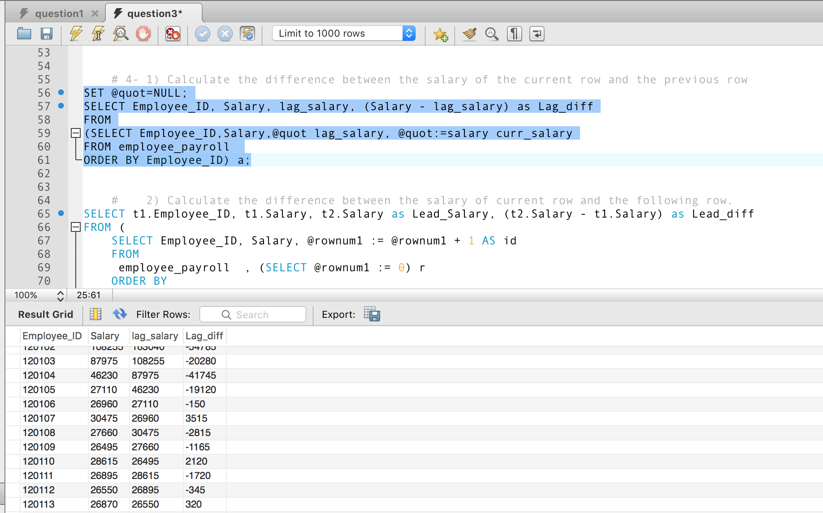

Figure3: Q3/4-1 Expression & Output – Displays 12 of 424

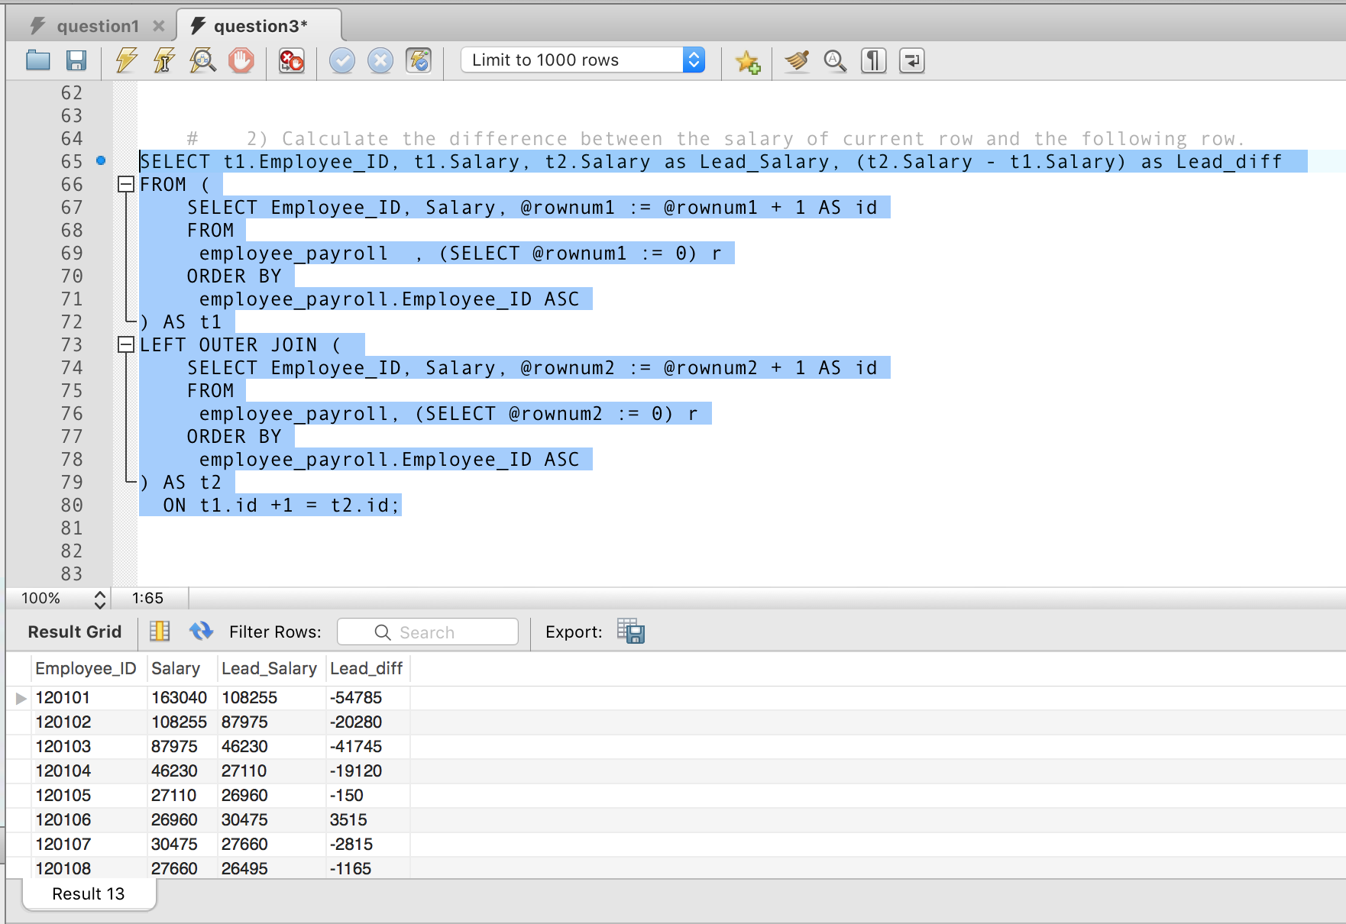

Figure4: Q3/4-2 Expression & Output – Displays 8 of 424